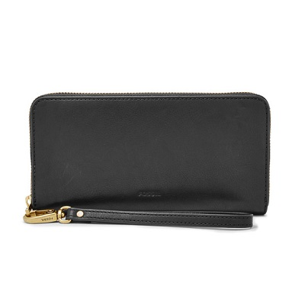

Emma RFID Large Zip Clutch

PRODUCT DETAILS

**Silhouette: Large Zip Clutch**

**Tech Compatibility: iPhone® 6 Plus, 7 Plus, 8 Plus**

**Exterior Material: Leather**

**Interior Details: 2 Bill Compartments, 12 Credit Card Slots, 1 Zipper Pocket and 3 Gusseted Pockets**

**Measurements: 7.88"L x 1"W x 4.38"H**

**Warranty: 1 Year Limited**